TABLE OF CONTENTS
1. POLICY AND SCOPE 2
2. RESPONSIBILITIES AND QUALIFICATIONS 4
3. DEFINITIONS 4
4. PROCEDURE 7
4.1. Riser Integrity Observation 7
4.2. AL Riser Inspection 11
4.3. 2-Inch AL Riser Inspection 17
4.4. AL Riser Casing Inspection 18
4.5. AL Riser Coating 20
4.6. AL Riser MRVs 23
4.7. Tracer Wire 28
4.8. Steel Risers 28
4.9. Initiating Follow-up Orders (Distribution) 31
5. EXCEPTION PROCEDURE 32
6. OPERATOR QUALIFICATION COVERED TASKS 33
7. RECORDS 33
8. APPENDICES 33
9. PROTECTED SECTIONS AND WORDING 33

PURPOSE: To provide guidelines and requirements for conducting and documenting integrity observation and/or inspection of Steel and/or Anodeless (AL) risers operating at 60 PSIG or less.
- POLICY AND SCOPE

  - Company employees and contractors must perform a service riser Inspection anytime there is a tools-type order, an Abnormal Operating Condition (AOC) is found or suspected, or an existing service valve is moved from the off position to the on position.
  - Company employees and contractors must perform a service riser observations when a service valve is shut off or there is a non tools-type order, in the vicinity of the meter, in accordance with this standard
  - Inspections of above-ground onshore service line for atmospheric corrosion are performed at least once every 5 calendar years, but with intervals not exceeding
63 months.
    - If atmospheric corrosion is found on a service line during the most recent inspection, then the next inspection of that pipeline or portion of pipeline must be within 3 calendar years, but with intervals not exceeding 39 months.
  - Inspections of above-ground offshore piping facilities for atmospheric corrosion are performed at least once every calendar year, but with intervals not exceeding
15 months.
  - AL Risers with a Mini Riser Vault (MRV), approved wax pad or wax tape coating, Polyken tape wrap, or composite repair kit in earth or paved installations, may be observed or inspected without removing the protective system, unless an AOC is present or suspected.
Note: Composite wrap repair kits are permanent and cannot be removed. If an AOC is present or suspected, the riser must be replaced.
  - AL risers passing inspection must be coated with a Company approved coating as described within this standard. Refer to Section 4.5 and GS G7376, Field Tape Wrapping Requirements.
  - Steel risers showing no signs of AOC's do not require a physical inspection.
  - All risers with AOCs must be repaired in accordance with this standard.
  - Hazardous Riser and MSA leaks require an immediate response and continuous action until a permanent repair is made.
Note: Until relieved by a qualified Company employee, a Company employee finding hazardous leak indications, must remain at the location performing activities to their ability and training to keep themselves, the public, and the area safe until the appropriate support personnel has responded to isolate, and correct the leak.
  - Service risers must be inspected prior to tent fumigation for AOC’s. Service risers that fail the inspection are to be repaired or replaced prior to tent fumigation.
    - Contact dispatch/FSD Scheduling or trouble immediately to have risers that are leaking replaced, prior to tent fumigation.
  - Each segment of pipeline that becomes unsafe must be replaced, repaired, or removed from service.
    - Each imperfection or damage that would impair the serviceability of the PE pipe or fitting must be repaired or removed.
  - When performing Observations or Inspections that lead to a non-emergency excavation or construction activities - Company organizations must provide no less than 3 working days' notice to the administration of a school, hospital and/or registered licensed day care facility prior to undertaking non-emergency excavation or construction of a gas pipeline, if work is located within 500-feet. Refer to GS G7402, Notification of Excavation and Construction Activities - Assembly Bill Number 1937/ PUC Code 955.5.
  - To comply with the purpose of Independent Inspections
    - Welding Training & Inspection Group is responsible for performing and documenting inspections at their discretion using the Smart Sheet App during medium pressure pipeline welding or PE pipe fusions operations. Refer to the FORM 2849SD, Construction Inspection Report.
Note: When an Independent Inspection is being performed, the personnel who performed the construction task (installing pipe, fusing, welding, etc.) requiring the inspection must not perform the Independent Inspection.
- RESPONSIBILITIES AND QUALIFICATIONS
  - Only Company employees trained and qualified through Gas Operations Training may perform the operations outlined in this Gas Standard. Refer to the following standards listed below:
- GS G7809, Qualification and Re-Qualification of Welders,
- GS D7293, Qualification Requirements for Polyethylene Fitters,
- GS D7907, Qualification Requirements Distribution Pressure Control, and
- GS G8113, Operator Qualification Program.
  - Company employees are responsible for adhering to company procedures and must wear appropriate personal protective equipment during all duties performed. Refer to MANUAL ESHSD-4100, Rule 4100, Gas Distribution and Transmission.
  - Company employees and contractors must meet the requirements for pressure control operations when working on the Company gas system. Refer to GS D7905, Requirements for Pressure Control Operations on Distribution Pipeline Systems.
  - Contractors are responsible for providing the training to their employees, ensuring their employees follow the procedures outlined in this Gas Standard, completing the Operator Qualification requirements, and scheduling their qualifications test through Gas Operations Training. Refer to GS G8113, Operator Qualification Program for further instructions on completing operator qualification requirements.
  - Contractors are responsible for adhering to their Company Safety Procedures and/or Practices and are expected to comply with applicable Federal, State, and Local laws, ordinances, and regulations to ensure the safety of their employees. Refer to
GS G8308, Contractor Safety Program and SDGE Contractor Safety Manual Class 1 Contractors.
  - Qualified Operators are responsible to visually inspect all pressure control equipment prior to performing any pressure control operation. Do not use any damaged or defective equipment
  - Pipeline Integrity is responsible for the process with integrity inspections and observations of risers as outlined within this standard.
  - Districts are responsible for implementing the procedures identified in this standard.
- DEFINITIONS
  - Acronyms:
- AL Riser - Anodeless Riser,
- AOC - Abnormal Operating Condition,
- CSF - Customer Service Field,
- FBE - Fusion Bonded Epoxy,
- MAOP - Maximum Allowable Operating Pressure,
- MSA - Meter Set Assembly,
- MRV - Mini Riser Vault,
- PPE - Personal Protective Equipment, and
- PE - Polyethylene.
  - Abnormal Operating Condition (AOC) - A condition identified by the company that may indicate there is a malfunction of a component or a deviation from normal operations and which may indicate a condition exceeding design limits or otherwise resulting in a hazard to the public, property, individuals, or the environment. As defined in GS D9103, Gas Distribution Terms and Definitions
  - Anodeless (AL) Riser - A gas service riser used for transitioning from below ground PE piping system to an above ground steel piping system, which does not require cathodic protection by eliminating buried gas-carrying steel piping. As defined in GS D9103, Gas Distribution Terms and Definitions.
  - Anodeless (AL) Riser Casing - A steel tubing component factory assembled AL risers that houses and protects the above ground portion of PE pipe and the steel-to-PE transition joint and provides for structural integrity of the assembly.
  - Anodeless (AL) Riser Vertical Protective Sleeve - A loose fitting plastic tube, sometimes with longitudinal slots, installed over the vertical leg of the riser to protect against external damage due to landscaping or similar activities.
  - Atmospheric Corrosion
    - Minor Atmospheric Corrosion - Corrosion which is uniformly distributed and does not result in significant material wall loss.
    - Significant Atmospheric Corrosion - Corrosion which is characterized by the presence of excessive blistering, pitting and/or spalling (flaking) resulting in significant material wall loss.
    - Swollen Coating - Bulging and possible splitting of any coating on the above ground portion of the riser. This is due to corrosion/rust under the coating and prevents observation of the true condition of the underlying steel.
    - Thru-Wall Casing Corrosion - A reported condition of an AL riser casing where the entire wall of the casing has been penetrated by corrosion resulting in a breach of the casing in the above ground portion of the riser, regardless of the size of the penetration.
  - Coating and/or Wrap
    - Coal Tar Pipe Wrap - A coating to protect steel risers from atmospheric corrosion which contains asbestos and should not be disturbed without proper training and PPEs.
    - Composite Wrap - An epoxy wrap that strengthens a structurally weak AL riser and protects the riser from atmospheric corrosion. It is considered a permanent repair.
    - Fusion Bonded Epoxy (FBE) - An epoxy-based powder coating that is widely used to protect pipeline components from corrosion. On AL risers, typically gray or green in color.
    - Polyken 930 Tape Wrap - A Company approved coating that is installed on steel and existing AL risers protecting them from atmospheric corrosion.
    - Wax Pad - A pad (coating) that is installed on AL risers protecting them from atmospheric corrosion. It is not intended to be used on steel risers.
    - Wax Tape - Special wax tape system used to protect bare steel from atmospheric corrosion, commonly used on AL risers, steel valves and above ground piping.
  - Dis-bonded - Any loss of adhesion between the protective coating (i.e., not limited to, wax pad, coal tar wrap, painted surface “bubbling” or “flaking”) and a pipe surface because of adhesive failure, damage, etc.
  - Failed Gauge - A reported condition of an AL riser gas-carrying nipple describing the result of the gauge inspection indicating that the riser has significant metal loss.
  - Final Grade - Ground level after landscaping or concrete/paving is completed.
  - Inaccessible - A service valve that cannot be accessed due to unforeseen field conditions.
  - In Earth Installations - A riser that is set in soil/ dirt with no paving or concrete.
  - Inspection - As it relates to this standard, anytime there is a tools-type order, an AOC is found or suspected, or an existing service valve is moved from the off position to the on position, a riser inspection is required.
  - Low AL Riser - An AL riser that is buried to the point where the gas carrying portion of the riser is in direct contact with soil.
  - Mini Riser Vault (MRV) - A high-density PE casing comprised of a body and cap designed to serve as a barrier against soil and debris intrusion. As defined in
GS D9103, Gas Distribution Terms and Definitions.
  - Observation - Is required anytime a service valve is shut off or there is company work in the vicinity of the meter. No documentation required unless, an AOC is found or suspected.
  - Riser - Pipeline system component used for transitioning from below ground piping systems to above ground steel piping systems.
  - Riser Inspection Tool - A type of gauge (Go/No-Go) used to assess metal loss of gas carrying ¾ and 1-inch steel nipples on AL risers.
  - Riser Nipple - The gas carrying steel nipple on an AL riser to which the service valve is attached. This nipple extends to varying lengths below the bottom of the service valve depending on size, manufacturer, and vintage, and must remain above ground or protected from soil contact.
  - Service Valve - A type of valve used to stop the flow of gas through a gas service piping system and is located (upstream) at the MSA.
  - Shrink Sleeve - A heat shrink plastic sleeve formed around the riser nipple, located just below the service valve. Can be green, black, or gray in color.
  - Tools-Type Order - A service order requiring the use of tools (i.e., pipe wrench) to install, replace or adjust fittings on the MSA. (e.g., Planned Meter Change, regulator change, MSA leak orders, or anytime the service valve is turned on).
- PROCEDURE
  - Riser Integrity Observation
- A service riser observation is required before a service valve is shut off, and prior to proceeding with an integrity inspection in accordance with this standard.
    - Observations require reporting when AOCs are found which may require remediation prior to proceeding with their work.
    - When working one or more orders at a meter manifold, only one observation is required.
    - A riser observation does not require tools to identify an AOC.
      - Qualified employees may use soap to determine if a leak is upstream or downstream of the service valve. Refer to GS D7265, Pneumatic Test Requirements for Pipelines Operating at 60 PSIG or Less.
      - Hazardous leaks require an immediate response and continuous action until a permanent repair is made.
    - Abnormal operating conditions to be identified and reported during the observation such as, but are not limited to:
- Gas leak,
- Inaccessible service valve,
- Broken service valve tang,
- Significant atmospheric corrosion,
- Unsecured tracer wire or tracer wire that can contact the MSA or a metallic object,
- Missing tracer wire,
- Swollen coating, and/or
- Thru-wall casing corrosion.
Note: There are various makes and models of AL risers currently in service that are referenced in this standard. (Refer to Appendix B for riser condition, appropriate mitigation, mitigation schedule, and policy section reference).
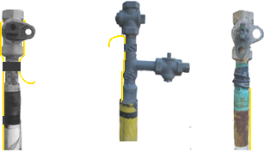
AL Riser Identification
FIGURE 1
    - Prior to making physical contact with the riser, MSA, or the houseline, a voltage test with a Company approved voltage detector must be conducted, refer to GS D7131, Testing for Electricity at the Gas Meter Set Assembly.
- If electricity is present, STOP THE JOB, secure the area, and contact supervisor/dispatch to contact appropriate personnel for assistance.
    - While approaching the location of the riser, look, listen, and smell for indications of a gas leak.
Field Collectors: Skip to Section 4.1.7.1.1.2.
      - If a gas leak is suspected, soap test the riser nipple to check for any gas leak. Refer to GS D7265, Pneumatic Test Requirements for Pipelines Operating at 60 PSIG or Less.
        - If leakage is found, STOP THE JOB, DO NOT ATTEMPT TO MAKE REPAIRS:
          - If qualified to classify or code leakage, refer to GS G8245, Above Ground Leakage Classification and Mitigation Schedules for above ground leakage and GS G8135, Leakage Classification and Mitigation Schedules for below ground leakage.
CSF: If leak indications are detected, refer to
GS C5510, Leak Investigation – Customer Service Field (CSF).
          - If not qualified to classify or code leakage, call Dispatch/FSD Scheduling/Trouble and standby until handed off to a gas crew to determine if the leak is Hazardous or Non- Hazardous.
CSF: If a leak is found by a CSF employee: Call trouble to request a gas crew and document as required. Standby until handed off to a gas crew to determine if the leak is Hazardous or Non- Hazardous or released.
    - If NO leakage is found, continue with the riser observation and/or inspection.
      - Observe the service valve and visually validate it is accessible and a wrench could be used to close and open the valve.
    - If the riser valve is identified as being in an inaccessible or inoperable condition, and the current work order requires turning the service valve off, STOP THE JOB. Do Not Proceed with the work until the valve is accessible and operational. Issue the appropriate field action order for corrective work. Refer to GS C5385, Maintenance & Lubricating of ¾" and 1" Service Valves.
    - If the riser service valve is identified as having a significant atmospheric corrosion condition, and the current work order requires turning of the service valve off, STOP THE JOB. Do Not Proceed with the work until the valve is made accessible and/or operational. Issue the appropriate field action order for corrective work.
      - For an illustration of an AL riser having significant atmospheric corrosion, refer to Figure 8 and Figure 9 below.
      - For an illustration of a steel riser having significant atmospheric corrosion, refer to Figure 19 below.
    - When the riser is Anodeless, observe and determine if a swollen coating condition exists on or around the gas carrying nipple area.

      - When the coating on the riser gas carrying nipple area is identified as being swollen, STOP THE JOB. Do Not Proceed with the work until the riser nipple has been inspected for adequate remaining wall thickness or it has been repaired. Issue the appropriate field action order for the corrective work.
Note: Swollen coating is required to be removed and the condition of the riser requires an evaluation. See Section 4.2.6. below.
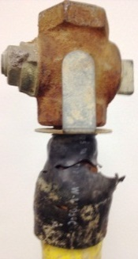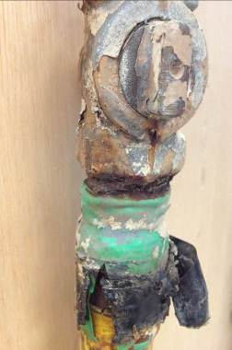
Swollen Coating Condition
FIGURE 2
    - Observe the above ground portion of the AL riser casing.
      - If corrosion has resulted in a hole completely thru the casing wall, (thru-wall corrosion) issue the appropriate field action order for the corrective work. See Figure 10 below.

    - AL riser casings found with a thru-wall corrosion condition, and the PE pipe is exposed, contact your supervisor or dispatch to request distribution to take action by the next business day. See Figure 10 below.

    - AL Risers with an MRV, company approved wax coating, Polyken tape wrap, or repaired with the composite repair kit in earth or paved installations, may be observed without removing the protective system unless an AOC is present or suspected.

Note: Composite wrap repair kits are permanent and cannot be removed. If an AOC is present or suspected, the riser must be replaced.
  - AL Riser Inspection
Note: During the inspection, closely examine the risers at soil to air interface, including: FBE coating, under thermal insulation, under disbonded coating, at any supports, through deck penetrations, in splash zones, and over water.
    - Prior to making physical contact with the riser, MSA, or the houseline, a voltage test with a Company approved voltage detector must be conducted, refer to GS D7131, Testing for Electricity at the Gas Meter Set Assembly.
- If electricity is present, STOP THE JOB, secure the area, and contact supervision/dispatch to contact appropriate personnel for assistance.
    - If the riser nipple and casing are visible and the riser sleeve and or shrink sleeve is not blocking the inspection process, proceed to Section 4.2.4 below.
    - Proceed to Section 4.2.4 below unless one or more of the following conditions exist prior to proceeding with the inspection:
- The Coating is swollen, proceed to Section 4.2.6 below,
- In Earth, if the gas carrying nipple/casing is low, proceed to
Section 4.2.7 below,
- In pavement or concrete, if the gas carrying nipple/casing is low, proceed to Section 4.2.8 below, and/or
- If shrink sleeve exists, proceed to Section 4.2.9 below.

    - Soap test the riser nipple to check for any gas leak. Refer to GS D7265, Pneumatic Test Requirements for Pipelines Operating at 60 PSIG or Less.
      - If leakage is found on an initial soap test of the riser nipple, STOP THE JOB, DO NOT ATTEMPT TO MAKE REPAIRS:
        - If qualified to classify or code leakage, refer to
GS G8245, Above Ground Leakage Classification and Mitigation Schedules for above ground leakage and
GS G8135, Leakage Classification and Mitigation Schedules for below ground leakage.
CSF: If leak indications are detected, refer to GS C5510, Leak Investigation – Customer Service Field (CSF).
        - If not qualified to classify or code leakage, call Dispatch/FSD Scheduling/ Trouble and standby until handed off to a gas crew to determine if the leak is Hazardous or Non- Hazardous.
CSF: If a leak is found by a CSF employee: Call trouble to request a gas crew and document as required. Standby until handed off to a gas crew to determine if the leak is Hazardous or Non- Hazardous.
    - If no leakage was found proceed to Section 4.2.10 below.
    - If the AL riser coating is swollen (Not Leaking) and the employee is concerned that continuing with the inspection may cause the riser to leak:
CSF STOP the riser inspection and call Dispatch/FSD Scheduling/Trouble to request a gas crew and document as required: (See Figure 2).
Stop the job situation - Need gas crew to take action same day.

      - Distribution employees must take appropriate safety precautions and continue with the riser inspection.
Note: The swollen coating is required to be removed and the condition of the riser requires evaluation to identify the remediation requirements, or replace the gas riser the same day if removing the swollen coating is a concern of creating a gas leak.
      - After evaluating the riser, if unable to complete the remediation or where the remediation is deferred, a follow-up work order must be scheduled and completed within 1 year from the initial date found, not to exceed 15 months.
    - In earth installations
      - Refer to Appendix A to assist in identifying whether the gas carrying nipple/casing connection is above final grade.
      - If the riser gas carrying nipple is above final grade, and there is a minimum height of ½-inch between the nipple/casing connection and final grade, proceed with the riser inspection process. See Figure 3 below.
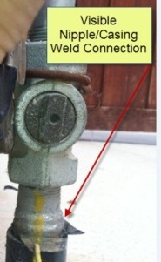
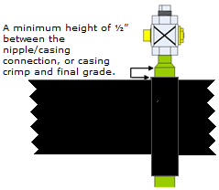
FIGURE 3
      - If the gas carrying nipple / casing connection is not visible, low in earth, remove the soil or ground covering away from the riser to allow for inspection.

Note: If a low in earth condition remains after the soil and/or ground covering has been removed, the AL risers can be raised utilizing a pre-made coupling and nipple combination, refer to GS D7341, Raising, Repairing, or Installing a Bypass on a ¾ and 1-Inch Steel or Anodeless Risers for pressure control guidelines. Make sure the AL riser is coated per Section 4.5 and an MRV is installed as per Section 4.6.

Note: If unable to complete remediation, issue the appropriate follow-up order.
      - Where remediation is deferred, a follow-up work order must be scheduled and completed within 2 years from the initial date found, not to exceed 27 months.
    - In paved installations
Note: The red Do not bury line is intended for positioning the riser during new installations and is NOT intended to be used during the riser inspection process.
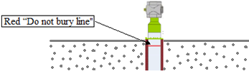
      - Refer to Appendix A to assist in identifying whether the gas carrying /casing connection is above final grade.
      - If the riser gas carrying nipple is above final grade, and there is a minimum height of ½-inch between the nipple/casing connection and final grade, proceed with the riser inspection process. Refer to Figure 3 above.
      - An AL riser is found low in paving must be remediated. For coring refer to GS D7250, Coring for Mini Riser Vault (MRV)Installation.
        - If needed, issue the appropriate follow-up order.
      - Where remediation is deferred, a follow-up work order must be scheduled and completed within 2 years from the initial date found, not to exceed 27 months.
CSF: Send a note via MDT to dispatch for follow-up.
      - If the AL riser is equipped with a protective sleeve and the protective sleeve is pushed up against the service valve, (see Figure 4 below) attempt to push the sleeve down to provide enough space between the sleeve and service valve to allow for a proper inspection.
        - A minimum of ½-inch between the nipple/casing connection and the sleeve must be visible to continue with the riser inspection. Refer to Figure 3 above, Figure 4 and Figure 5 below.
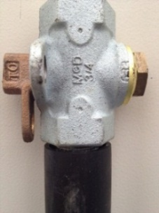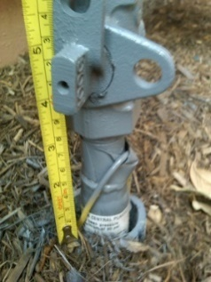
FIGURE 4 FIGURE 5
      - If unable to push the sleeve down to the desired level and provide a sufficient gap between the service valve and protective sleeve, the sleeve should be cut and removed so the riser can be properly inspected.
Note: Use CAUTION while cutting and removing the protective sleeve to not damage the AL riser.

CSF: Send a note via MDT to dispatch for follow-up.
    - If a shrink sleeve exists, remove the shrink sleeve by cutting through the sleeve with a sharp linoleum knife.
Note: Always assess the condition of the riser before removing shrink sleeves, ID ring, rust, and scale. On significantly or excessively corroded riser nipples, these actions can result in the creation of leaks.
      - Clean off the exposed riser nipple with a wire brush and soap test after cleaning. Refer to GS D7265, Pneumatic Test Requirements for Pipelines Operating at 60 PSIG or Less.
      - If leakage is found, STOP THE JOB, DO NOT ATTEMPT TO MAKE REPAIRS:
        - If qualified to classify or code leakage, refer to
GS G8245, Above Ground Leakage Classification and Mitigation Schedules for above ground leakage and
GS G8135, Leakage Classification and Mitigation Schedules for below ground leakage.
CSF: If leak indications are detected, refer to GS C5510, Leak Investigation – Customer Service Field (CSF).
        - If not qualified to classify or code leakage, call Dispatch/FSD Scheduling/ Trouble and standby until handed off to a gas crew to determine if the leak is Hazardous or Non- Hazardous.
CSF If a leak is found by a CSF employee: Call trouble to request a gas crew and document as required. Standby until handed off to a gas crew to determine if the leak is Hazardous or Non- Hazardous.
      - If NO leakage is found, continue with the riser inspection.
    - Inspect the exposed portion of the riser nipple for pitting. Use the riser inspection tool (Go/No-Go riser inspection tool gauge) to determine if the riser has metal loss and needs to be repaired or replaced. See Figure 6 for Go/No-Go riser inspection tool gauge.
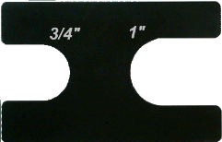
FIGURE 6
    - If the Go/No-Go gauge can slide over the ¾ or 1-inch riser, the riser has significant/excessive metal loss and has failed the inspection, issue the appropriate follow-up order. Refer to Figure 7 below.
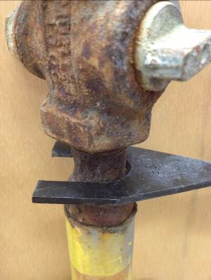
FIGURE 7
      - All AL risers that fail the gauge must be replaced or remediated in accordance with GS D7251, Composite Coating Repair for Anodeless Risers.
        - If unable to complete remediation or where remediation is deferred, a follow-up work order must be scheduled and completed within 1 year from the initial date found, not to exceed 15 months.
        - Paint the exposed steel portion of the riser to provide rust protection until the riser can be repaired.
  - 2-Inch AL Riser Inspection
    - For 2-inch AL risers, inspect the riser for significant atmospheric corrosion, pitting, and thru-wall casing corrosion. If any of these conditions exist, issue an order to replace the riser as soon as practical, not to exceed 10 business days unless the riser casing can be supported with a stainless-steel clamp.
Note: When supported by a stainless-steel clamp, the PE pipe must not be visible and must be protected from UV light.

CSF: If corrosion has resulted in 360-degree metal loss and the structural integrity of the riser has been compromised (refer to example in Figure 9), STOP THE JOB. Stop the riser inspection. Call Dispatch/FSD Scheduling/ Trouble and stand-by until handed off to gas crew to take action the same day.
      - When the integrity of the riser has been strengthened through use of a clamp, remediation may be deferred, a follow-up work order must be scheduled and completed within 1 year from the initial date found, not to exceed 15 months.
        - Paint the exposed steel portion of the riser to provide rust protection until the riser can be replaced.
Note: AL risers scheduled for replacement do not require the approved coating or MRV's to be installed.
  - AL Riser Casing Inspection
    - Inspect the above ground portion of riser casing.
CSF: If corrosion has resulted in a hole completely through the casing wall, see Figure 8 and Figure 10, STOP the riser inspection, and send note via MDT to dispatch for follow-up. If corrosion has resulted in 360-degree metal loss and the structural integrity of the riser has been compromised (see example in Figure 9), STOP the riser inspection and call Dispatch/FSD Scheduling/Trouble and stand-by until handed off to gas crew to take action the same day.
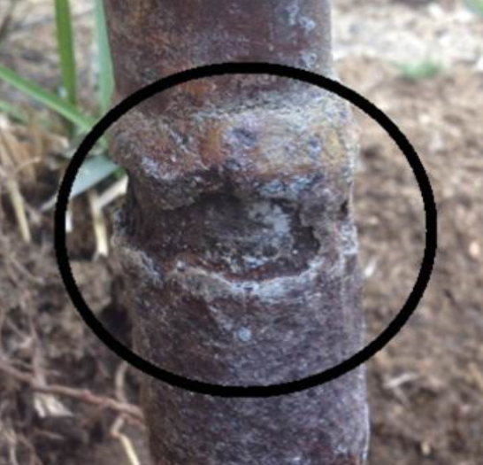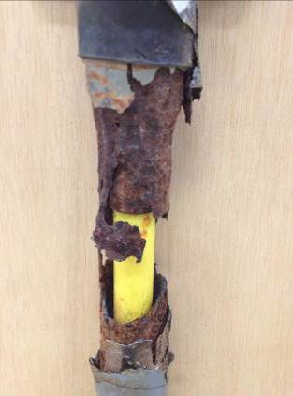
FIGURE 8 FIGURE 9
    - Prompt remedial action must be taken for AL riser casings found with 360-degree metal loss and the structural integrity of the riser has been compromised. See Figure 9 above.
    - AL riser casings found with thru-wall corrosion, or exposed PE pipe (See Figure 10) conditions must be replaced as soon as practical, not to exceed 10 business days unless the riser casing can be supported with a stainless-steel clamp.
      - When supported by stainless steel clamp, the PE pipe can no longer be visible and must be protected from UV light and an order to replace riser is to be issued. Riser replacement must be scheduled and completed within 1 year from the initial date found, not to exceed 15 months.
Note: In situations where the riser needs to be replaced the same day or the next business day, the employee must contact supervision and share all pertinent information.

Note: For underground service alert and temporary marking requirements, refer to
GS G8123, Underground Service Alert and Temporary Marking.
For notification requirements to qualifying School, Hospital and / or Registered Licensed Day Care Facility within 500-feet proximity prior to planned (non-emergency) construction excavation activity on a gas facility. Refer to Section 1.13.
      - For AL risers with casing corrosion or thru wall corrosion that can be supported with a stainless-steel clamp, the severity of corrosion, riser condition, weight, and size of the MSA, and deferred date must be taken into consideration (refer to Figure 10 for example of an AL riser that can be clamped, refer to Figure 9 for an example of an AL riser that cannot be clamped).
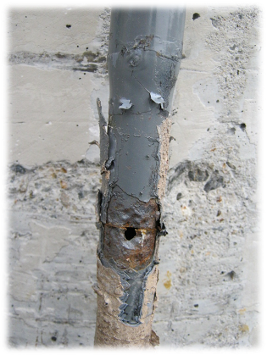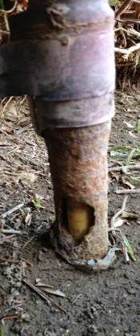
FIGURE 10
        - When riser replacement is deferred, a follow-up work order must be scheduled and completed within 1 year from initial date found, not to exceed 15 months.
      - For composite repairs to be possible, holes in the riser casing must be backed by the internal steel nipple, and no exposed PE pipe can be visible. Refer to GS D7251, Composite Coating Repair for Anodeless Risers.
        - When riser replacement or composite repair is deferred, a follow-up work order must be scheduled and completed within 1 year from initial date found, not to exceed 15 months.
  - AL Riser Coating
    - AL risers, regardless of finish grade, must be coated with an approved wax pad coating, wax tape coating or Polykene 930 Tape Wrap.
Note:
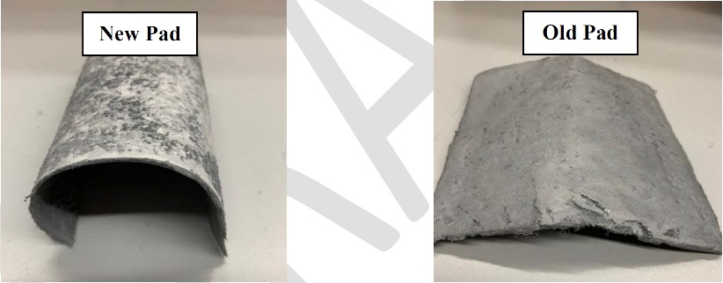
The Trenton 6 x 6-inch wax pads has a shelf life of 9 months from the date of manufacture. However not all packaging may have a date visible on the packaging/box.
If a date is not visible prior to installation, inspect the wax pads to determine the wax pads are still good to install.
Bend a single wax pad into a u-shape as it would be to form around a gas riser. The wax pad should feel soft and pliable, hold its shape, and adhere to itself. See New Pad pictured above.
If the wax pad does not hold its shape, firm or stiff in texture, and does not adhere to itself, it must not be used for installation and must be properly disposed of. See Old Pad picture above.
This product contains mineral spirits, under no circumstances should any heat source or open flame be used to warm up the product to attempt to make it more pliable.

    - Existing ¾ and 1-inch AL Risers Inspected and Clean
Note: AL risers must be inspected and clean prior to installing the Company approved coating.
      - If the riser is equipped with a tracer wire and/or an Excess Flow Valve (EFV) identification tag, move the tracer wire and/or EFV tag away from the riser before applying the Company approved coating.
      - Wearing approved gloves or using an acid brush, spread a thin layer of primer (material code S557704) on the riser, from the bottom of service valve to a minimum of ½-inch below the existing non-damaged coating. See Figure 11 below.
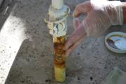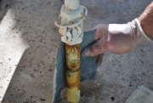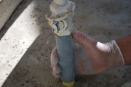
FIGURE 11
      - Apply the approved 6 x 6-inch wax pad to the area that has been primed and a minimum of ½-inch below the existing non-damaged coating. (Wax pad, material code S720812.)
      - Position the wax pad around the riser and up to the bottom of the service valve, overlapping the edges. Thoroughly massage and compress the seams and edges to create a water-tight seal.
      - AL risers with a by-pass will require additional pads to coat the horizontal nipple leading out to the by-pass valve, including the vertical nipple to the by-pass valve, overlapping the edges. Thoroughly massage and compress the seams and edges to create a water-tight seal.
Note: The 6 x 6-inch wax pads are the preferred coating to use on 1-inch and below AL risers with a bypass, however the approved 2-inch x 9-foot rolls of wax tape (material code S720090) may be used, or the Polyken 930 tape wrap (material code S720032) and Polyken 1039 Liquid Adhesive Primer (material code S557696) instead.
      - If the area to be coated exceeds the 6 x 6-inch wax pad because the riser was raised using a pre-made riser nipple or inadequate coating, additional pads will be required. Apply the wax pad from the bottom portion of primed area, ensuring the wax pad overlaps the existing non-damaged coating, and maintain a 1-inch minimum overlap until the coating has reached the bottom of the service valve(s).
      - If the riser has an approved vertical sleeve, and the sleeve is positioned correctly, attempt to push the protective sleeve down so the wax pad or Polyken 930 tape wrap does NOT overlap the protective sleeve. If unable to push the sleeve down to the desired level, the protector sleeves should be cut and removed so the wax pad does not overlap the protective sleeve. See Figure 12 below.
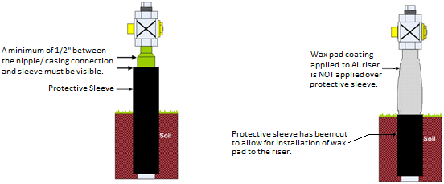
FIGURE 12
Note: If space is limited, the wax pad may be folded or cut as necessary to create a water-tight seal from the bottom of the service valve to a minimum of ½-inch below the existing non-damaged coating.

Note: During cold weather, the wax pad may become stiff and difficult to form around the riser. However, a water-tight fit can be achieved by thoroughly massaging and compressing the seams and edges to create a water-tight seal.

Note: Disposal of items associated with using the wax coating or Polyken products, i.e., gloves and rags, are to follow local Region Environmental practices.
      - Re-attach the tracer wire to the AL riser on the outside of the approved coating. Refer to GS D7257, Tracer Wire Installation for Polyethylene (PE) Pipe Installations.
      - All Excess Flow Valve identification tags (material code S716456) removed during the AL riser inspection procedure must be reinstalled on the outside of the approved coating.
    - Existing 2-Inch AL Risers Inspected and Cleaned
Note: The AL riser must be inspected and cleaned prior to installing the AL riser coating.
      - If the riser is equipped with a tracer wire and/or an Excess Flow Valve (EFV) identification tag, move the tracer wire and/or EFV tag away from the riser before applying the approved coating.
      - Apply the approved 2-inch x 9-feet roll of wax tape or Polyken 930 Tape wrap a minimum of 1-inch below the existing non-damaged coating. (Wax tape, material code S720090. (Polyken 930 tape wrap (material code S720032) and Polyken 1039 Liquid Adhesive Primer (material code S557696)).
        - Thoroughly massage and compress the seams and edges of the wax tape to create a water-tight seal.
Note: During cold weather, the wax tape may become stiff and difficult to form around the riser. However, a water-tight fit can be achieved by thoroughly massaging, compressing the seams and edges to create a water-tight seal.

Note: Disposal of items associated with using the wax coating or Polyken products, i.e., gloves and rags, are to follow local Region Environmental practices.
      - Re-attach the tracer wire to the AL riser on the outside of the company approved coating. Refer to GS D7257, Tracer Wire Installation for Polyethylene (PE) Pipe Installations.
      - All Excess Flow Valve identification tags (material code S716456) removed during the AL riser inspection procedure must be reinstalled on the outside of the company approved coating.
    - New or Replaced AL Risers
      - New or replaced AL risers must be coated with a company approved wax pad or wax tape coating, refer to GS D7247, Service Risers for Polyethylene (PE) Installations.
Note: Polyken products are not to be used for new or replaced AL risers, only during remediation and repair of existing risers.

  - AL Riser MRVs
    - Earth application for ¾ and 1-inch AL risers.
      - The MRV assembly consists of; the MRV body
(material code S653480), MRV cap (material code S352488), and cable tie (material code S738440).
      - MRV’s are required for AL risers that are set low in earth, and pass the inspection process, and are coated with company approved coating or composite repair kit.
Note: MRV’s are required to be installed on AL risers that were raised using the pre-made riser nipple combination.
      - All Excess Flow Valve identification tags (material code S716456) removed during the AL riser inspection procedure must be reinstalled on the outside of the approved coating, and MRV body shown in Figure 13 below.
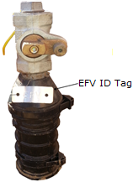
FIGURE 13
Note: Risers treated with the composite wrap repair kit will be required to have an MRV body and cap assembly installed only if a low in earth condition exist.
      - Place the existing locating wire through the notch within the MRV cap as you assemble the MRV components.
        - If the tracer wire is short, you may extend wire using appropriate method if qualified. Refer to GS D7257, Tracer Wire Installation for Polyethylene (PE) Pipe Installations.
Note: Do not allow bare copper wire to remain against any metallic portion of the riser and/or MSA.
      - Install the MRV body and cap assembly:
- Around the riser approximately ½-inch from the bottom of the service valve, not to exceed 1-inch below the bottom of the service valve,
- The top of the MRV cap must be exposed above final grade, and the bottom of the body MUST be below ground level, and
- Secure the MRV assembly with zip ties and cut off the excess tail of the zip ties. See Figure 14 below.
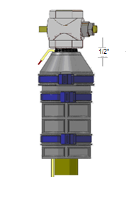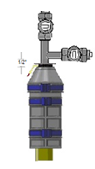.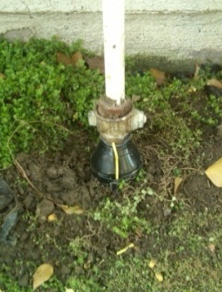
FIGURE 14
Note: Should the need arise that requires a longer MRV body, such as a raised risers using a nipple combination, the MRV body can be extended by attaching a second MRV body to the bottom of the first body.
This will increase the overall height by 6-inches.
The second MRV body may be trimmed down if needed, to accommodate existing field conditions if the gas carrying nipple is contained within the MRV body.
Risers that need more than two MRV bodies will require distribution follow-up to determine if an AOC exists. Issue the appropriate execution order for follow-up work. Refer to Figure 15 below for an illustration of an extended MRV body.
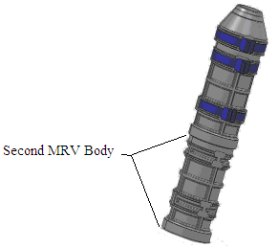
FIGURE 15
    - Paved/Concrete application for ¾ and 1-inch AL risers.
      - MRV’s are not required for AL risers in paving/concrete that pass the inspection process and are coated with company approved coating or composite repair kit provided the riser is set at the appropriate height, and NO coring or drilling is required.
        - MRV’s are required to be installed on all AL risers which require coring or drilling or are set low in earth. See Figure 16 below.
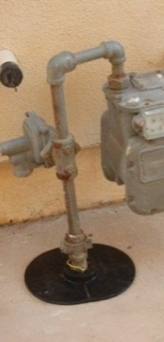
FIGURE 16
Note: All Excess Flow Valve identification tags (material code S716456) removed during the AL riser inspection procedure must be reinstalled on the outside of the company approved coating, or the MRV, if installed. See Figure 17 below.

Note: MRV’s are required to be installed on risers which require coring or drilling, and/or risers that were raised using the pre-made riser nipple combination.
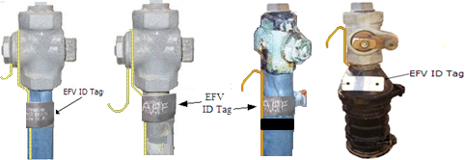
FIGURE 17
    - 2-inch riser in earth or paved application.
      - MRV’s are not required for AL risers in earth or paving that are set to the appropriate height, and NO coring or drilling is required.
      - MRV’s are required to be installed on all AL risers which require coring or drilling or are set low in earth. See Figure 18 below.
        - Install the MRV body and cap assembly
(Material Code S790458)
- Around the 2-inch AL riser and secure the component halves with zip ties and cut off the excess tail of the zip ties.
Note: The component halves are larger and will require two zip ties joined together to secure the component as required.

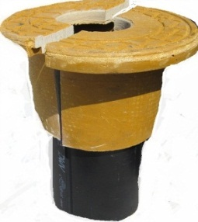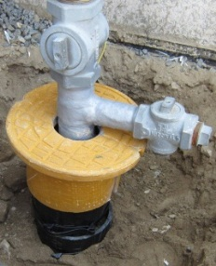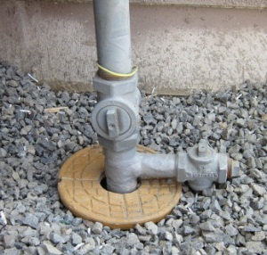
FIGURE 18
Note: All Excess Flow Valve identification tags (material code S716456) removed during the AL riser inspection procedure must be reinstalled on the outside of the company approved coating, and/or the MRV, if installed.
  - Tracer Wire
    - Missing Tracer wire
      - If no wire is found on the riser, with a pair of company approved gloves, gently displace dirt around the riser and or move ground cover out of the way. If the wire is found at or below ground level, extend the tracer wire per GS D7257, Tracer Wire Installation for Polyethylene (PE) Pipe Installations.
      - If tracer wire is not found, issue the appropriate follow-up order.
CSF: For all risers needing corrective action will utilize the “Send Note To” feature on the MDT.
      - Where remediation is deferred, a follow-up work order must be scheduled and completed within 2 years from the initial date found, not to exceed 27 months.
    - Unsecured tracer Wire
      - Wire that can contact the MSA or a metallic object should be secured when found. Refer to GS D7257, Tracer Wire Installation for Polyethylene (PE) Pipe Installations.
  - Steel Risers
    - Prior to making physical contact with the riser, MSA, or the houseline, a voltage test with a Company approved voltage detector must be conducted, refer to GS D7131, Testing for Electricity at the Gas Meter Set Assembly.
- If electricity is present, STOP THE JOB, secure the scene, and contact supervision/dispatch to contact appropriate personnel for assistance.
    - Steel risers showing no signs of AOC's do not require any additional action.
    - Steel Risers with AOC's must be repaired as required.
    - Riser coatings must be visually inspected. Deteriorated or damaged coating must be removed, and the exterior of the pipeline inspected.
CAUTION: If the original wrap on a pipeline is coal tar and is older than 1987, or if unsure of the year it was installed, presume it to contain asbestos. To prevent the release of airborne asbestos, all disturbed surfaces must be wet down with water. All debris must be bagged and disposed of per the procedures in Environmental GS G8321, Asbestos Management.
      - If during an inspection, external corrosion requiring remedial action is found; investigate circumferentially and longitudinally beyond the exposed portion to determine whether additional corrosion requiring remedial action exists by one of the following methods:
- Visual examination.
- Contact the appropriate supervisor (Distribution or Transmission) if assistance is required in determining the extent of the corrosion.
- Indirect methods capable of measuring metal loss or remaining wall thickness.
- If leakage or excessive metal loss is suspected to result from induced AC voltage (AC Corrosion); contact Pipeline Integrity, Integrity Assessment and Remediation, refer to Induced High Voltage Alternating Current (HVAC) on Pipelines, GS G8037, Induced High Voltage Alternating Current (HVAC) on Pipeline.
      - For risers identified as having small areas of external generalized corrosion, clean and recoat the exposed pipe as required per
GS G7376, Field Tape Wrapping Requirements.
      - For risers identified as having a Significant Atmospheric Corrosion condition and subsequent work requires operation of the service valve:
CSF STOP THE JOB, Stop the riser inspection, and do not proceed with the work. Issue the appropriate execution order for corrective work. See Figure 19 below of an example of a steel riser with Significant Atmospheric Corrosion.
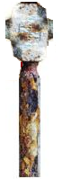
FIGURE 19
Note: Distribution will refer to GS G8021, Inspection of Exposed Pipe for guidance on corrective actions for cathodic protection for steel risers.
      - If the riser is identified as having heavy corrosion and pitting found on a pipeline operating at greater that 60 PSIG, refer to
GS G8021, Inspection of Exposed Pipe:
- Report pipe and coating condition on
FORM 677-1SD, Pipeline Condition and Maintenance Report and route to Technical Services, Region Engineer and to Gas Engineering -Pipeline Integrity.
- When the maximum depth of corrosion is 10-percent or less of the nominal wall thickness, the pipe is suitable for continued service at the established MAOP. No further evaluation is required.
- When the maximum depth of corrosion is greater than
10-percent, evaluate the corroded area, refer to
GS G8023, Predicted Failure Pressure Analysis for Corrosion Metal Loss.
- Repair or replace the riser or reduce the MAOP if the riser cannot be qualified to remain at the established MAOP.
      - For steel riser found to be low in earth (see Figure 20 below) and the service valve is touching the earth and or the service valve cannot be operated, remove the soil away from the riser. If the employee is NOT able to resolve the low condition, the riser must be raised as required, refer to GS D7341, Raising, Repairing, or Installing a Bypass on a ¾ and 1-Inch Steel or Anodeless Risers and Figure 21 below.
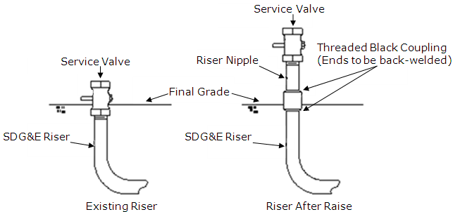
FIGURE 20 FIGURE 21
      - Leaking risers or leaking service valves that cannot be corrected must be addressed in accordance with GS G8135, Leakage Classification and Mitigation Schedules.
        - If qualified to classify or code leakage, refer to
GS G8245, Above Ground Leakage Classification and Mitigation Schedules for above ground leakage and
GS G8135, Leakage Classification and Mitigation Schedules for below ground leakage.
CSF: If leak indications are detected, refer to GS C5510, Leak Investigation – Customer Service Field (CSF).
        - If not qualified to classify or code leakage, call Dispatch/FSD Scheduling/Trouble and standby until handed off to a gas crew to determine if the leak is Hazardous or Non- Hazardous.
CSF If a leak is found by a CSF employee: Call trouble to request a gas crew and document as required. Standby until handed off to a gas crew to determine if the leak is Hazardous or Non- Hazardous or released.
  - Initiating Follow-up Orders (Distribution)
    - If the riser requires replacement due to leakage, initiate an order and classify or code the leak, refer to GS G8245, Above Ground Leakage Classification and Mitigation Schedules for above ground leakage and GS G8135, Leakage Classification and Mitigation Schedules.
    - If not qualified, call Dispatch/FSD Scheduling/Trouble to request a gas crew to inspect that day. Classification or coding type will be assigned after gas crew assesses the severity of the leak.
    - For non-leaking AL risers needing corrective action, initiate one of the three work types to plan and report all remedial actions performed to repair the AL riser:
- A follow-up work order to replace the AL riser as soon as practical, not to exceed 10 business days,
- A follow-up work order must be scheduled and completed within 1 year from the initial date found, not to exceed 15 months, or
- A follow-up work order must be scheduled and completed within 2 years from the initial date found, not to exceed 27 months.
    - Inform the customer an employee will return to repair or replace the riser.
    - If the customer is not home, leave a FORM SD3994, Sorry We Missed You Notice informing the customer that further repairs are needed, and an employee will return. Contact dispatch to 'Memo' the customer's account indicating that the riser was inspected, and an employee will be returning to perform additional work.
- EXCEPTION PROCEDURE
(Refer to GS G7007, Exception Procedure for Company Operations Standards)
  - An exception to this standard shall be considered only after all practicable solutions have been exhausted. All proposed exceptions to this standard must take safety issues into primary consideration and must comply with all relevant governing codes before approval of any proposed exception may be granted.
  - An exception to this standard shall be permitted only if GS G7007, Exception Procedure for Company Operations Standards, is followed, and approval is granted by those required by G7007.
- OPERATOR QUALIFICATION COVERED TASKS
(Refer to GS G8113, Operator Qualification Program, Appendix A, Covered Task List)
Note: When working under span of control, the qualified individual directing and observing the non-qualified individual is accountable for the work and must be physically present during task performance and must be recorded on all documentation as the qualified individual performing the work.
  - Task 02.01 49 CFR 192.459 – Examining buried pipeline when exposed.
- Task 02.02 49 CFR 192.461 – Properly applying external protective coatings for corrosion control.
- Task 02.13 49 CFR 192.481 – Monitoring for atmospheric corrosion.
- Task 02.15 49 CFR 192.487 – Recognizing General and Localized Corrosion, Taking Action (Distribution).
- RECORDS
  - This policy falls under the Record Classification Code OPS-20-04 in the Record Retention Schedule and must be retained for (Active + 75 Years).
  - Distribution - All risers needing corrective action must be recorded in SAP.
  - CSF – For all risers needing corrective action will utilize the “Send Note To” feature on the MDT.
- APPENDICES
  - Appendix A- Additional Guidelines for AL Risers Found in Paving
  - Appendix B - Summary of Inspection Results and Appropriate Mitigation for AL Risers
- PROTECTED SECTIONS AND WORDING
The following sections and wording in this document cannot be altered or deleted without prior approval from Pipeline Safety & Compliance and Legal:
Section | Protected Wording  (Underlined ONLY) | Justification | Date Wording Added
Not Applicable

APPENDIX A
Additional Guidelines for AL Risers Found in Paving
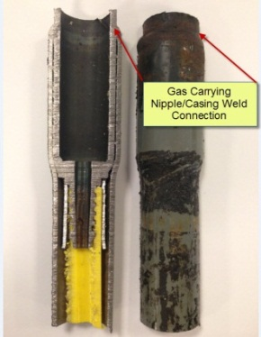
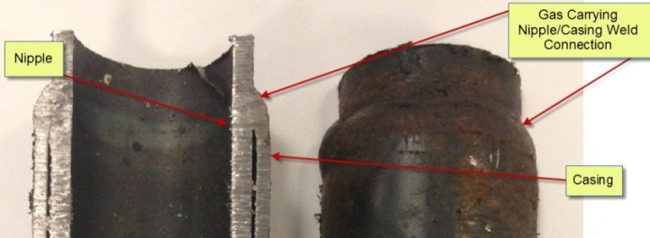

Exhibit A

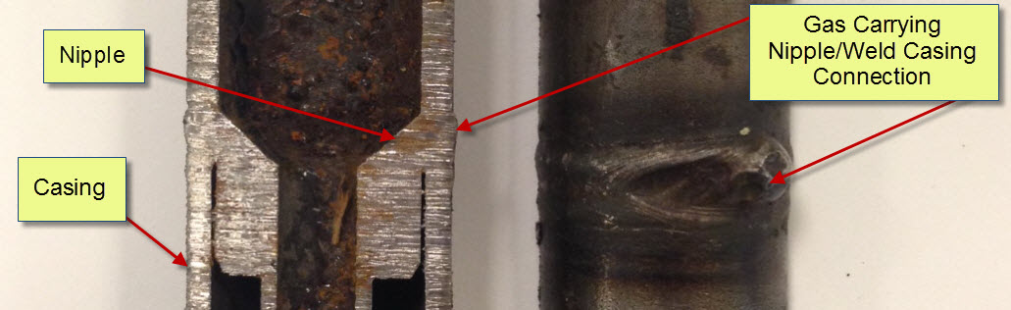
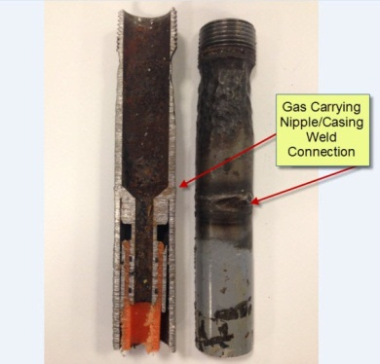
Exhibit B

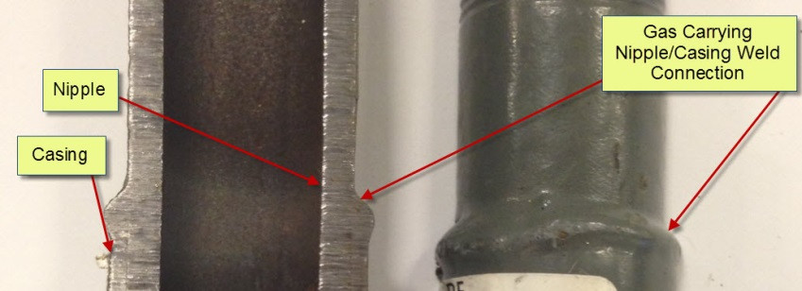
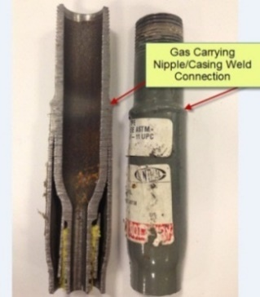

Exhibit C

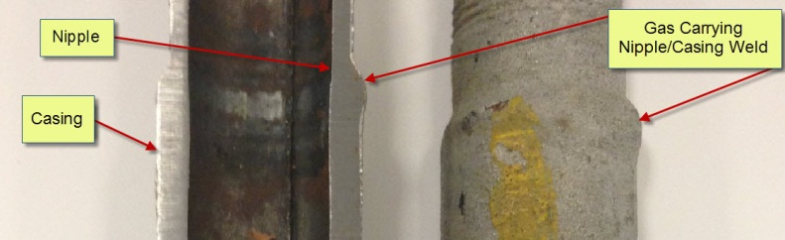
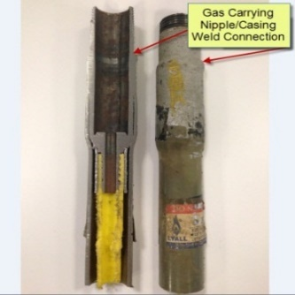

Exhibit D

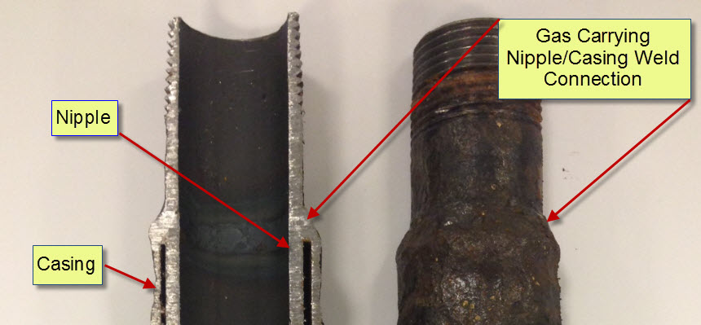
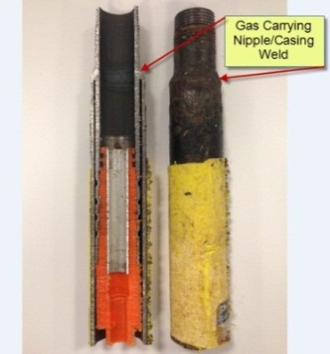

Exhibit E

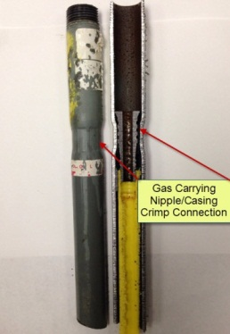
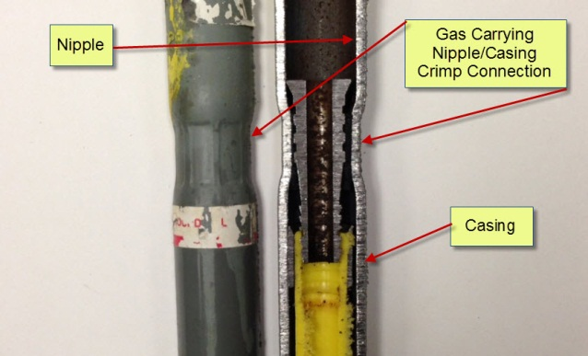

Exhibit F

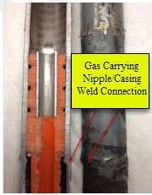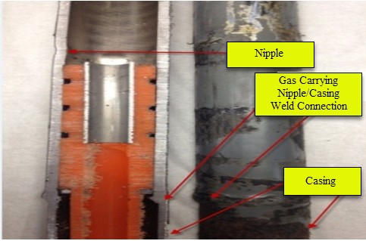
Exhibit G
APPENDIX B
Summary of Inspection Results and Appropriate Mitigation for AL Risers
Condition | Conditions | See Section | Appropriate Mitigation | Mitigation Schedule
AOC |  | 1.1, 1.5 & Note, 1.7, 1.8, 1.10, 3.1, 3.2, 3.13, 3.16, 4.1.2, 4.1.4, 4.1.5, 4.1.14 & Note, Note before Figure 14, 4.8.2, 4.8.3
 | Gas Leak | 1.9 & Note, 1.10.1, 4.1.4 thru 4.1.5, 4.1.7 thru 4.1.8, 4.2.4 thru 4.2.6,Note below 4.2.6.1, Note below 4.2.9, 4.2.9.2 thru 4.2.9.3, 4.8.4.1, 4.8.4.6 thru 4.9.2. | STOP WORK and take appropriate action based on conditions found. | Gas Leak - Refer to GS G8135, Leakage Classification and Mitigation Schedules
 | Electricity Detected | 4.1.6 & 4.1.6  4.2.1 & 4.2.1.1  4.8.1 & 4.8.1.1 | STOP WORK and take appropriate action based on conditions found. | Electricity – Contact Supervision Immediately, refer to GS D7131, Testing for Electricity at the Gas Meter Set Assembly.
 | Swollen Coating | 3.6.3, 4.1.5  4.1.11 thru Note  4.2.3  4.2.6 and Note.  3.6.3, 4.1.5  4.1.11 thru Note  4.2.6 thru Note below 4.2.6.1. | CSF - STOP WORK and take appropriate action based on conditions found.  Distribution – Remove swollen coating to evaluate riser, if needed composite repair or replace riser and install approved AL riser coating. | Stop the job, Need distribution to take action same day.  After evaluating the riser, if unable to complete remediation, schedule and complete within 1 year from the initial date found, not to exceed 15 months.

PE Riser in Earth/ Dirt: | Condition | See Section | Appropriate Mitigation | Mitigation Schedule
 | Everything is good:  Not low  No Thru-wall corrosion.  Passes gauge | 4.5 | Install approved AL riser coating.
 | Thru wall (360 corrosion) | Note below 4.3.1, Note above Figure 8 & 9. See Figure 9  4.4.2 and Note. | Replace riser and install approved AL riser coating. | Immediate
 | Thru Wall Corrosion (not 360) or exposed PE pipe. | 4.4.3,  4.9.2 | Replace riser and install approved AL riser coating. | As soon as practical, not to exceed 10 business days
 | *Thru Wall Corrosion (poly showing until clamped) supported with Stainless Steel Clamp/ poly no longer visible. | 4.4.3.1,  4.9.2 | Replace riser. | *Schedule and complete within 1 year from initial date found, not to exceed 15 months.
 | Thru Wall corrosion, backed by internal steel nipple (no poly showing) * | 4.4.3.3 thru 4.4.3.3.1, 4.9.2 | *Composite repair or replace riser and install approved AL riser coating. | *Schedule and complete within 1 year from initial date found, not to exceed 15 months.
 | Fails Go/No-Go gauge* | 3.9  4.2.11 thru 4.2.11.1.2  Figure 6 & Figure 7, 4.9.2 | *Composite repair or replace riser and install approved AL riser coating. | *When replacing, schedule and complete within 1 year from initial date found, not to exceed 15 months.
 | Low in Earth | 3.14, 4.2.7.3 down to the Note, 4.6.1.2, Figure 13 and Note, Figure 14, Note after Figure 14 and before Figure 15, 4.6.2.1.1, 4.6.3.2 and Figure 18, 4.9.2 | Displace dirt/ground covering or raise riser utilizing a pre-made coupling and nipple combination and Install MRV and approved AL riser coating. | Schedule and complete within 2 years from the initial date found, not to exceed 27 months.
PE Riser in Paving / Concrete | Condition | See Section | Appropriate Mitigation | Mitigation Schedule
 | Not low. No corrosion. Passes go/no-go gauge. Everything is good. | 4.5 | Install approved AL riser coating.
 | Fails gauge. Not low in paving | 3.9,  4.2.11 thru 4.2.11.1.2,  Figure 6 & Figure 7, 4.9.2 | Install composite coating repair | Schedule and complete within 1 year from initial date found, not to exceed 15 months.
 | Low in paving | 4.6.2, 4.6.2.1.1,  Figure 16, 4.6.3.2,  4.9.2 | Core drill, Install MRV and install approved AL riser coating. | Schedule and complete within 2 years from the initial date found, not to exceed 27 months.
 | Low in paving, fails go/no-go gauge ** | 4.2.8.3,  4.2.11.1,  4.6.2.1.1,  4.9.2 | Core drill: install composite coating and MRV or replace riser and install approved AL riser coating. | **Schedule and complete within 1 year from initial date found, not to exceed 15 months.
 | Low in paving, plus thru-wall corrosion with steel showing ** | 4.2.8.3,  4.4.3.3,  4.6.2.1.1,  4.9.2 | **Core drill: install composite coating and MRV or replace riser and install approved AL riser coating | Schedule and complete within 1 year from initial date found, not to exceed 15 months.
 | Missing Tracer Wire | 4.7.1 thru 4.7.1.3 | Find, extend, and attach the tracer wire | Schedule and complete within 2 years from the initial date found, not to exceed 27 months.
 | Unsecured tracer wire that can contact the MSA or a metallic object | 4.7.2 thru 4.7.2.1 | Secure when found. | Secure when found.
Steel Riser | Condition | See Section | Appropriate Mitigation | Mitigation Schedule
 | Electricity Detected | 4.8.1 | STOP WORK and take appropriate action based on conditions found | Electricity – Contact Supervision Immediately. Refer to GS D7131, Testing for Electricity at the Gas Meter Set Assembly.
 | Gas Leak | 4.8.4.6 | STOP WORK and take appropriate action based on conditions found | Gas Leak - Refer to GS G8135, Leakage Classification and Mitigation Schedules.
 | Damaged Coating | 4.8.4 | Deteriorated or damaged coating must be removed, and the exterior of the pipeline inspected.
 | Everything looks good.  Not low | 4.8.2 | No additional action required. | No additional action required.

NOTE: Do not alter or add any content from this page down; the following content is automatically generated.
Brief: Policy was revised in Section 4.1.5 to list additional AOCs. Added note below Section 4.5.2 and 4.5.3, The AL riser must be inspected and clean prior to installing the AL riser coating. Section 4.5.2.8, 4.5.3.3, Figure 1 & 17, and Appendix "B" were revised for additional clarity on tracer wire. Added a new Section 4.7, Tracer wire. Section 4.5.2.9 and 4.5.3.4 were revised to add additional clarity on re-installing removed tags on AL risers. Reformatted Appendix B. Updated Hyperlink Titles.

Document Profile Summary
Responsible Person: | Stone, Kimberly D - KStone@sdge.com
Published On: | 1/1/2024
Last Full Review Completed On: | 11/28/2022
Next Review Due Date: | 10/31/2027
Document Status: | Active
Doc Type: | GAS
Category (Prior FCD system only):
If Merged, Merged To Document Number:
Utility: | SDG&E
Department: | Gas Infrastructure Programs & Support
Number of Common Document (if applicable): | 184.0121
Confidential Sections:
Contains OPQUAL Covered Task: | Yes
Part of SoCalGas O&M Plan: | No
Part of SDG&E O&M Plan: | Yes
Last O&M Review date: | 8/25/2025
Writer: | Nolin, Robert
O&M 49 CFR Codes & Impacted Sections of Document: | 192.703(c): 1.10,4  192.613(a): Entire Doc  192.481(b): Note below 4.2  192.481(a): 1.4, 1.5  192.481(c): 4.5
Part of Non-O&M Parts 191-193 Plan: | Yes
Non-O&M 49 CFR Codes & Impacted Sections of Document: | 192.311: 1.12.1
Impacts API1171: | No
API1171 Codes & Impacted Sections of Document:
Impacts API1173: | No
API1173 Codes & Impacted Sections of Document:
Part of Distribution IMP (DIMP): | Yes
Part of Transmission IMP (TIMP): | No
Part of Storage IMP (SIMP): | No
Impacts GO112F: | No
GO112F Codes & Impacted Sections of Document:
Impacts GO58A: | No
GO58A Codes & Impacted Sections of Document:
Impacts GO58B: | No
GO58B Codes & Impacted Sections of Document:
Part of CA PUC: | No
CA PUC Codes & Impacted Sections of Document:
Impacts New Business Construction: | No
Indices/Binders in Which Document is Filed: | CFSD, CSFSD, DIMP2, GSSD
Informed By:
NOP Learning Module (LM) Training Code: | NOP01384

